How to submit an article to the Workshop on Neutron Cross Section Covariances
A.A. Sonzogni,^{1*} B. Pritychenko²
¹ National Nuclear Data Center, Brookhaven National Laboratory, Upton, NY 11973-5000, USA
² NNDC, BNL, Upton, NY 11973-5000, USA

We describe in some detail how to submit an article to the Workshop on Neutron Cross Section Covariances. Authors can submit articles in either LaTeX or Microsoft Word formats. The articles will be published in the December 2008 issue of Nuclear Data Sheets.

I. Introduction
A Workshop on Neutron Cross Section Covariances will be held from June 24-June 27, 2008 (Tuesday morning - Friday noon) in Port Jefferson, New York. The Workshop is organized by the National Nuclear Data Center which is part of Brookhaven National Laboratory.
II. Proceedings
Proceedings will be published in the December 2008 issue of Nuclear Data Sheets (similar to the December 2007 and December 2006 issues). Articles should be around 5 pages long. All contributions will be subject to a peer-review process. Each registered participant will receive a copy of the proceedings.
A. Submitting a contribution
Articles will be published using LaTeX. Authors will submit the material electronically by e-mailing it to cw2008@bnl.gov. Participants can submit their articles in LaTeX or in Microsoft Word. In the latter case, the article will be converted in LaTeX by the NNDC.
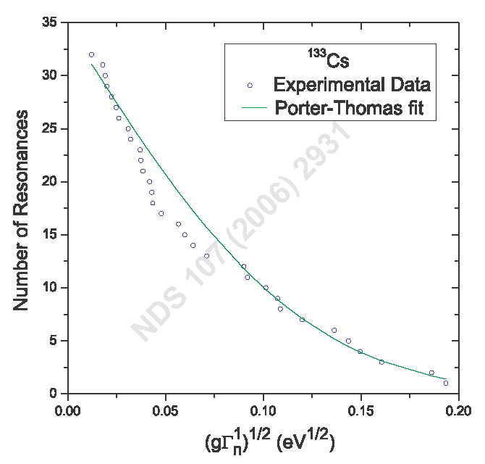
Authors should also submit the figures in Encapsulated Postscript (eps) format, that is, for each figure in the article, authors should submit an eps file. Let us know if you have problems creating eps files, the NNDC production staff may be able to help in this area.
We will also need a PDF version of the article so we will have an idea of the article’s layout as intended by the authors. The need of a PDF version is high for submission in LaTeX, it is not so important for articles in MS Word.
The first version of the article should be submitted by June 27, 2008. The very final version of the article should reach the NNDC by October 31st, 2008. Articles submitted after the October 31st will not make it into the December issue.
In summary, to make a contribution, authors should send an e-mail to cw2008@bnl.gov with the following attachments:
- Article in LaTeX or Word.
- One eps file per each figure in the article (highly recommended)
- A PDF version of the article (highly recommended).
III. Article layout using MS Word
Sections are numbered with Roman numbers. The name of the section is centered and the font is bold and 12 pt in size. Subsections are listed with capital letters, the name of the subsection is centered and the font is bold and 11 pt in size. Bullet lists are listed with regular numbers.
Paragraphs throughout the body of the article have a first line indentation of 0.2 inches and a line spacing after of 6 pt.
The article uses Times New Roman font. The body uses a 10 pt size.
IV. Figures
Because the body of the article has a two-column structure, figures should be able to shrink into a 3.6 in wide column without becoming unreadable.
Once shrunk, the writing on the plot should approximately match the article’s font in style and size, that is, Times New Roman at 10 pt.
Each figure should have a caption, an example is given below:

FIG. 1: Porter-Thomas distribution for ¹³³Cs.

The use of color in the figures is encouraged to enhance their understanding. The online version of the article will have the figures in color. This feature is optional for the printed version, as each page printed will cost about $300. Authors should communicate with the NNDC if they want their articles printed in color; if positive, authors will have to pay directly to Elsevier the cost of color printing. The articles layout may change to minimize the number of pages printed in color, which will reduce the cost of the publication. As mentioned before, it will be greatly appreciated if authors send eps versions of each figure in the article.
V. Tables
An example of a table fitting in one column is given below:
TABLE I: Major releases of the ENDF/B library.

ENDF/B | IV | V | VI | VII
Year | 1974 | 1978 | 1990 | 2006

Authors can also submit tables wider than a single column or going over more than one page. Each table must have a caption.
VI. Making References
As an example, a reference to the big ENDF/B-VII.0 article [1] is given. Please note that authors should provide the title of the work in question. Reference [2] is an example of a citation to a conference proceeding. If you are using MS word, please notice the hanging indentation.
Acknowledgments
We are grateful to all the people that helped us with this work. Work at Brookhaven National Laboratory was sponsored by the Office of Nuclear Physics, Office of Science of the U.S. Department of Energy under Contract No. DE-AC02-98CH10886 with Brookhaven Science Associates, LLC.

*) Corresponding author, electronic address: sonzogni@bnl.gov
[1] M.B. Chadwick et al., “ENDF/B-VII.0: Next Generation Evaluated Nuclear Data Library for Nuclear Science and Technology “, Nucl. Data Sheets vol. 107, p. 2931, 2006.
[2] M. Herman et al., “Recent extensions and use of the statistical model code EMPIRE”, in Proc. of the Inter. Conf. on Nuclear Data for Science and Technology (R. Haight, M. Chadwick, T. Kawano and P. Talou, eds.), New York, USA, p. 1184, Santa Fe, Sept. 26 - Oct. 1, 2004, Amer. Inst. of Physics, 2005.

